Freeform Mixed Shapes
# Source: AI Source: Provided by: [Data Path: Persons Table -> ID Column: 1, Name_En Column: Motasem Essam] -> From: [ChatGPT] on [7/25/2026]
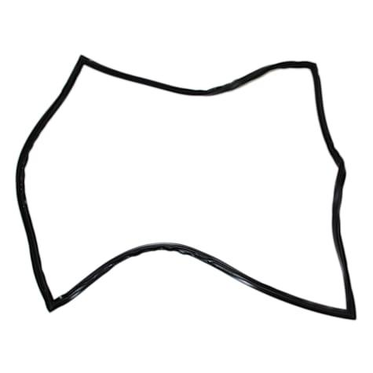
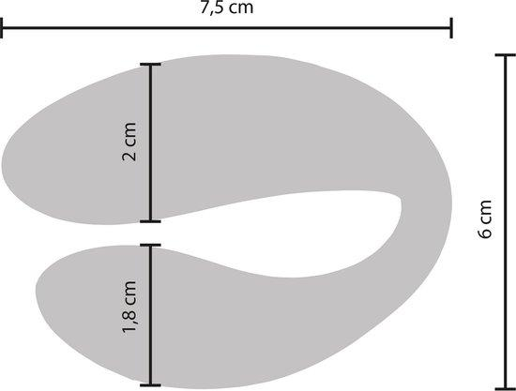
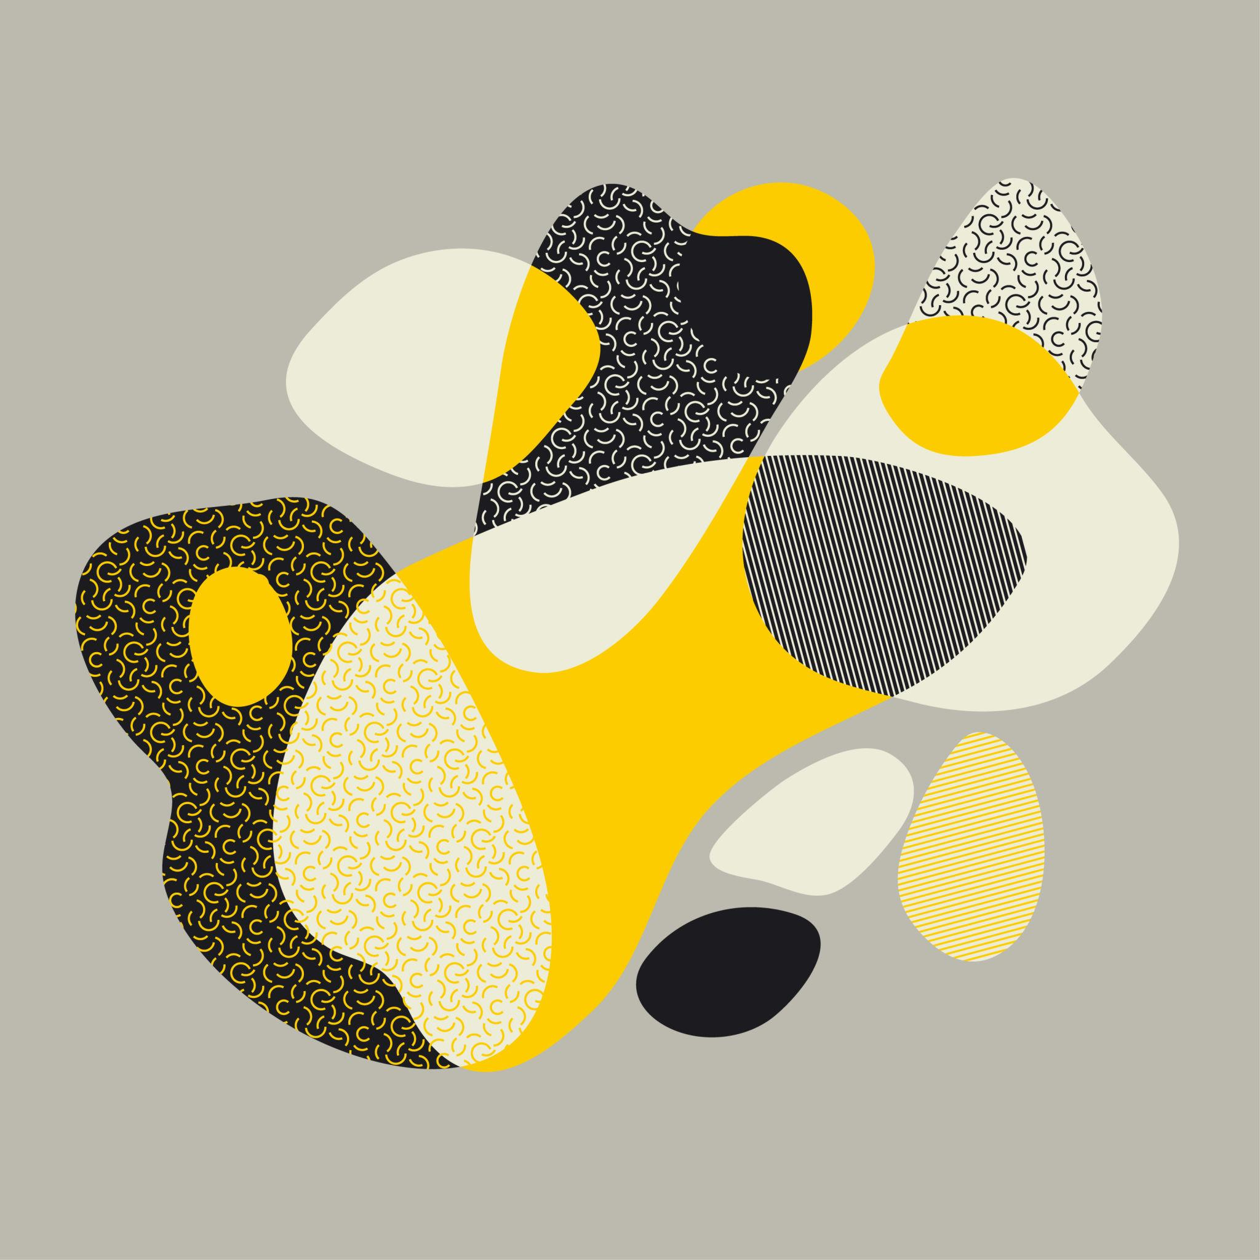
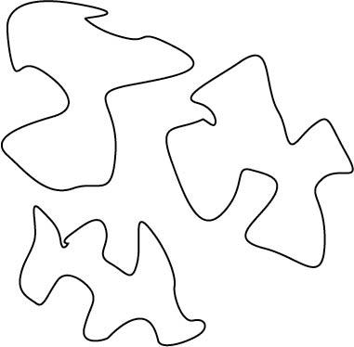
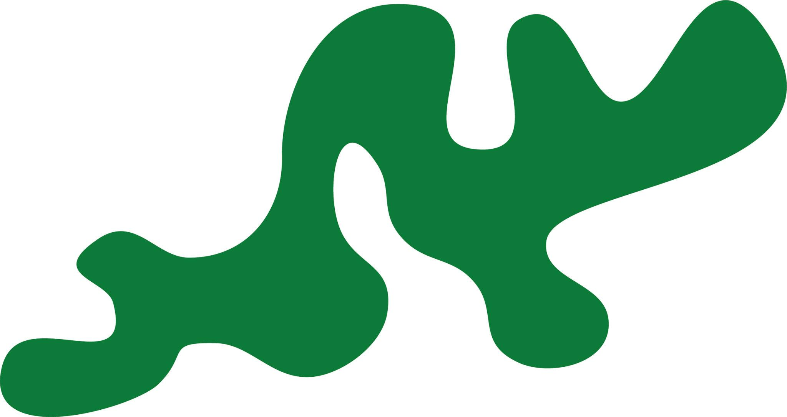

Definition
# Source: AI Source: Provided by: [Data Path: Persons Table -> ID Column: 1, Name_En Column: Motasem Essam] -> From: [ChatGPT] on [7/25/2026]
A Freeform Mixed Shape is an irregular shape that combines different types of geometric boundaries or components—such as straight line segments, circular arcs, and freely controlled curves—without following one standard geometric form.
In simple terms:
It is a custom-designed irregular shape that combines straight and curved elements in a freely controlled form.
$$\boxed{\text{Freeform Mixed Shape}=\text{Multiple Boundary Types}+\text{Irregularity}+\text{Freeform Construction}}$$

Characteristics
# Source: AI Source: Provided by: [Data Path: Persons Table -> ID Column: 1, Name_En Column: Motasem Essam] -> From: [ChatGPT] on [7/25/2026]
A freeform mixed shape typically:
- Is usually closed when used as a shape or region.
- May contain both straight and curved boundaries.
- Can contain circular arcs and freeform curves.
- Has variable curvature.
- Does not follow a single standard geometric shape.
- Does not require symmetry.
- May contain polygonal, circular, organic, or spline-based components.
- Can be designed manually or generated using CAD/vector tools.
- May have a highly complex boundary.

Common Types

1. Polygon–Freeform Mixed Shape
# Source: AI Source: Provided by: [Data Path: Persons Table -> ID Column: 1, Name_En Column: Motasem Essam] -> From: [ChatGPT] on [7/25/2026]
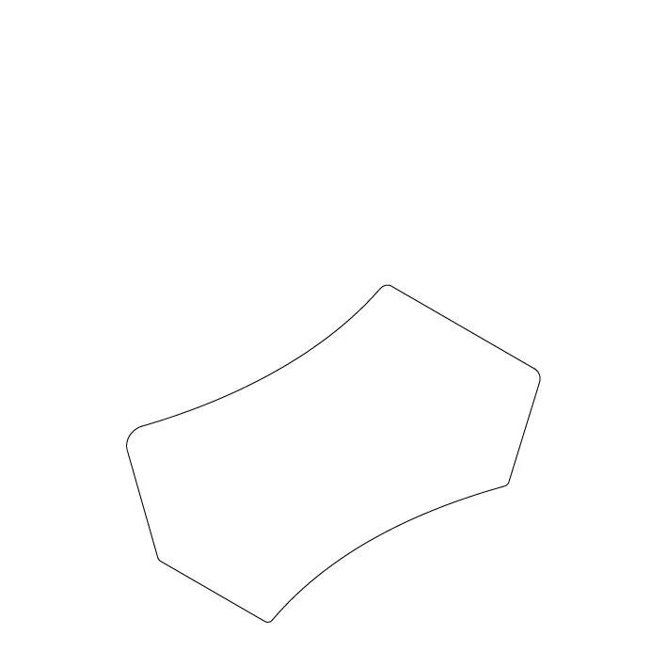
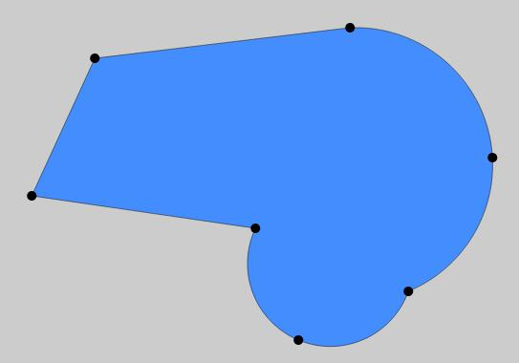
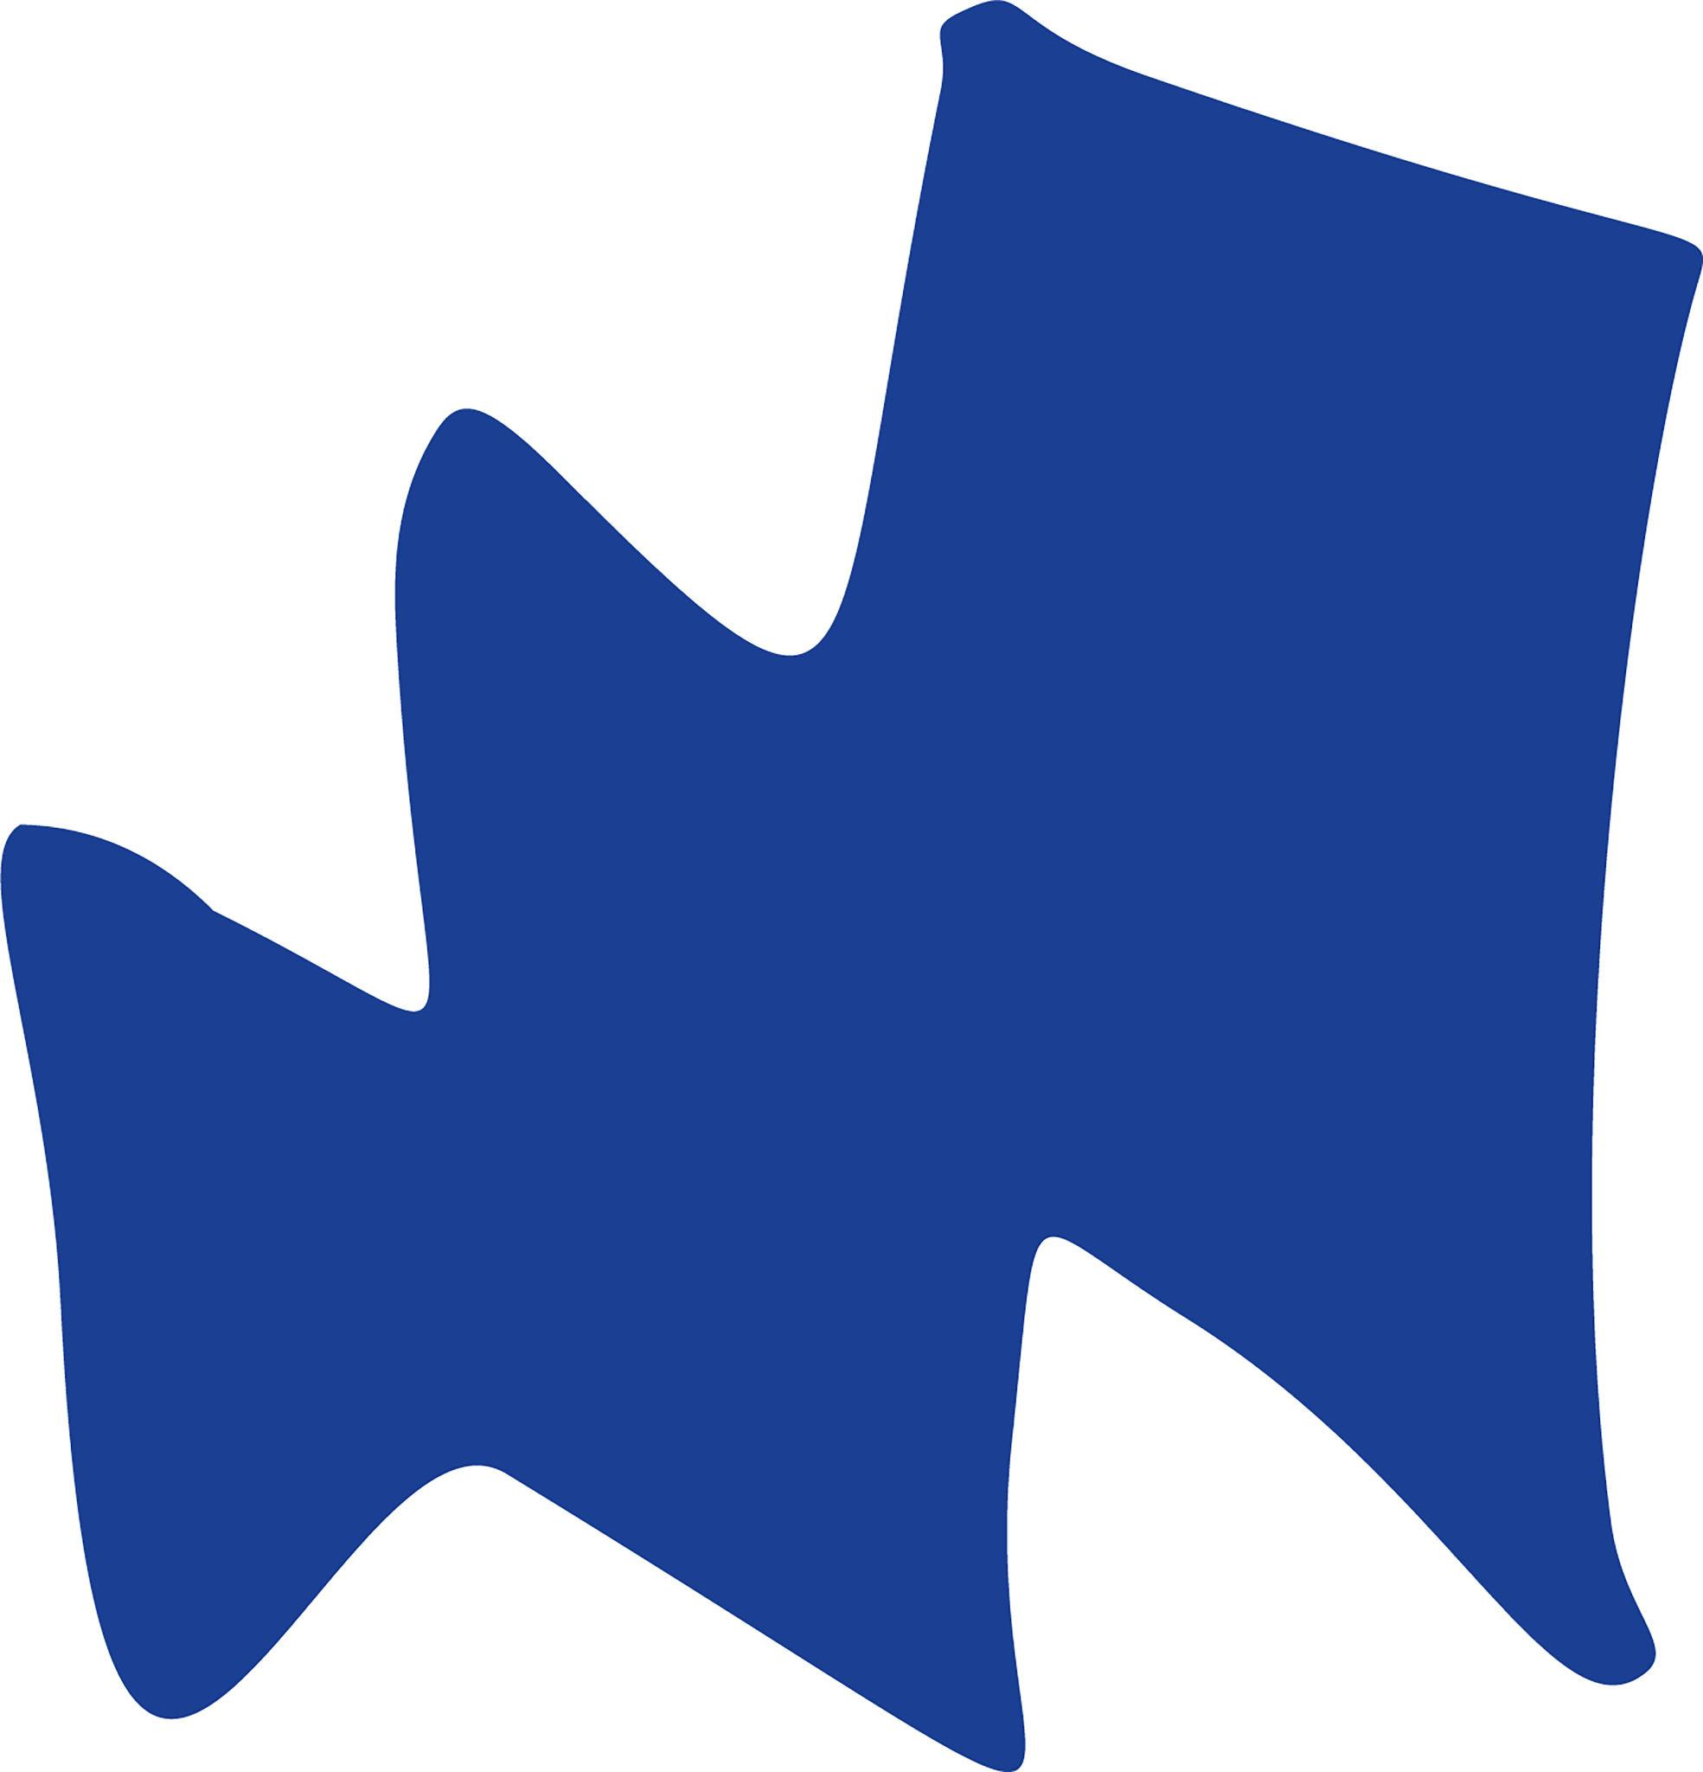
Combines polygonal straight edges with freely controlled curved sections.
$$\boxed{\text{Polygonal Parts}+\text{Freeform Curves}}$$

2. Rectangle–Freeform Mixed Shape
# Source: AI Source: Provided by: [Data Path: Persons Table -> ID Column: 1, Name_En Column: Motasem Essam] -> From: [ChatGPT] on [7/25/2026]
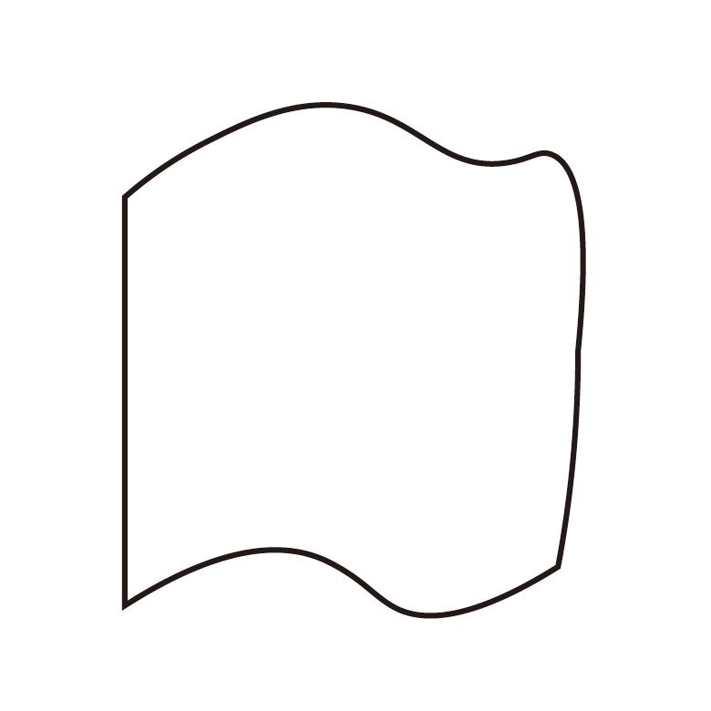
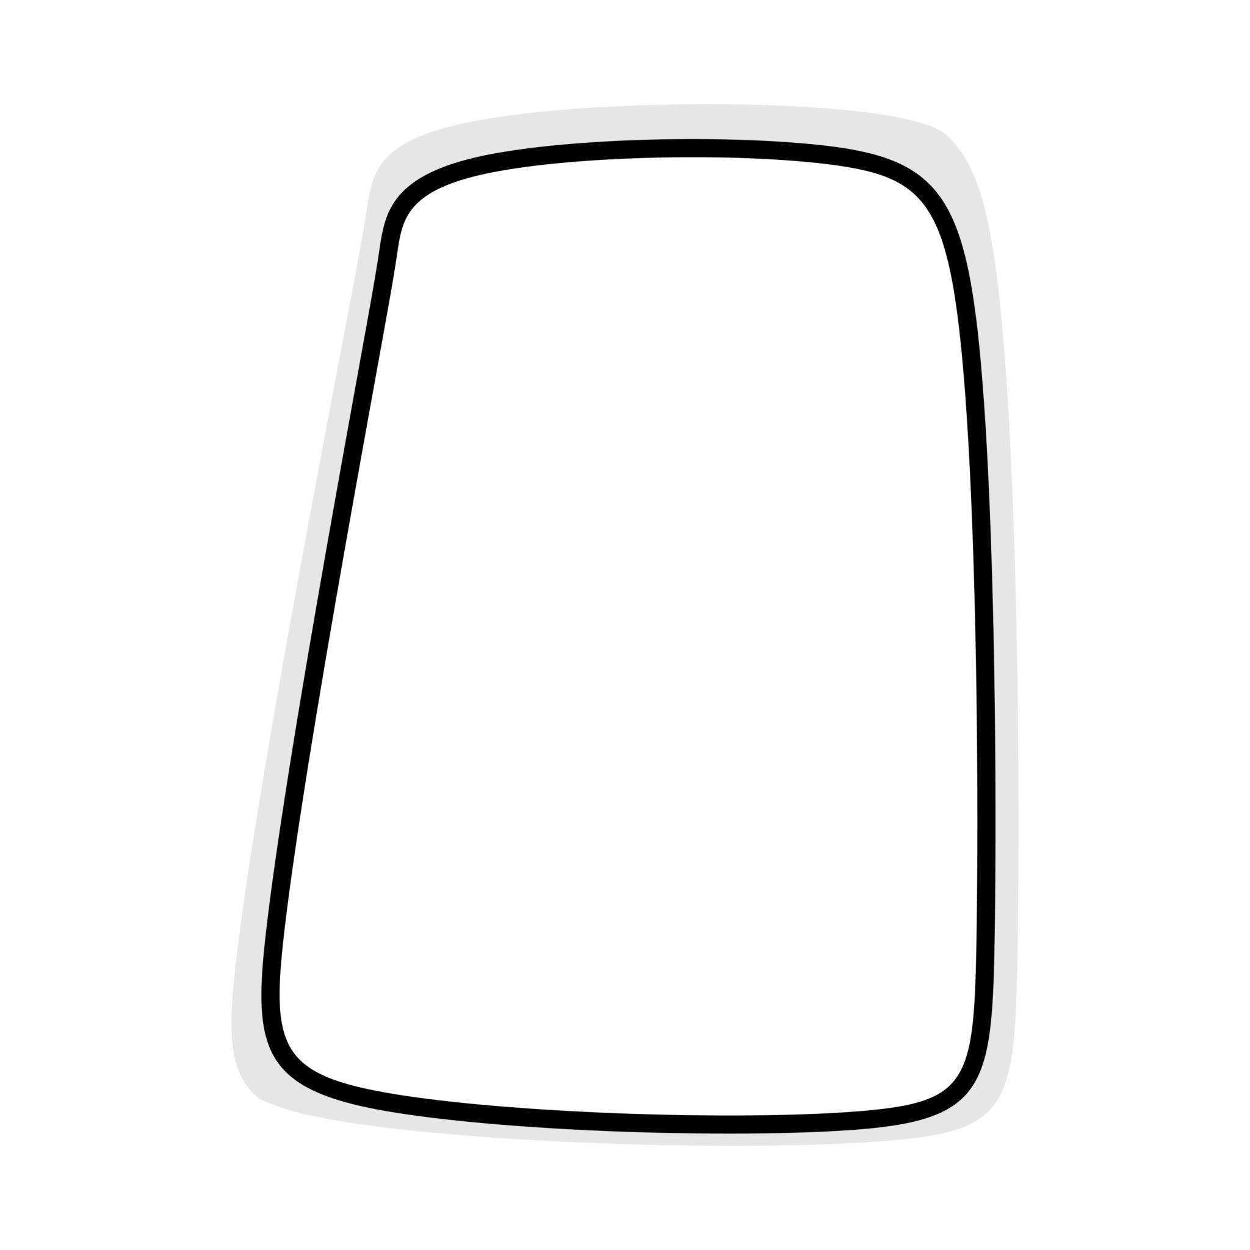
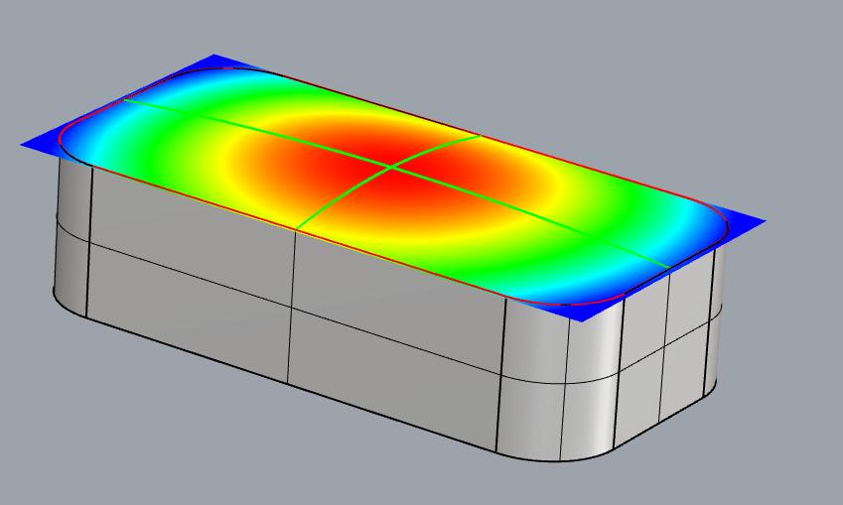
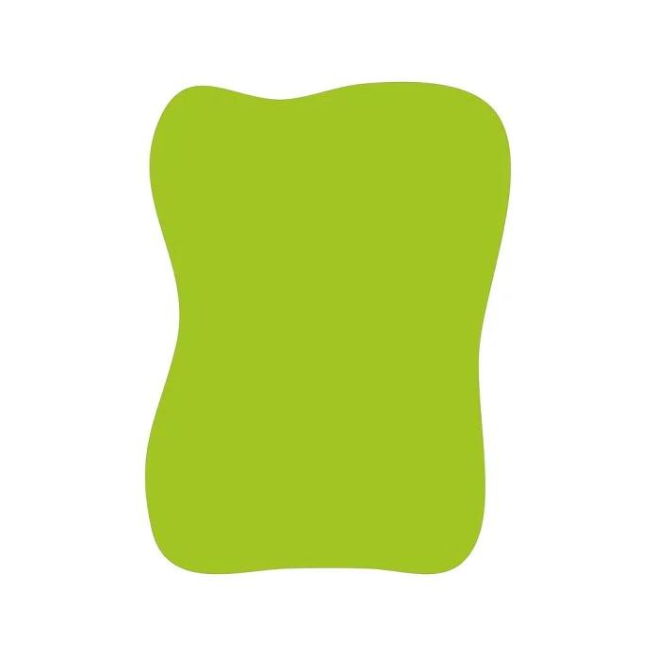
A rectangular component is combined with one or more custom curves.

3. Triangle–Freeform Mixed Shape
# Source: AI Source: Provided by: [Data Path: Persons Table -> ID Column: 1, Name_En Column: Motasem Essam] -> From: [ChatGPT] on [7/25/2026]
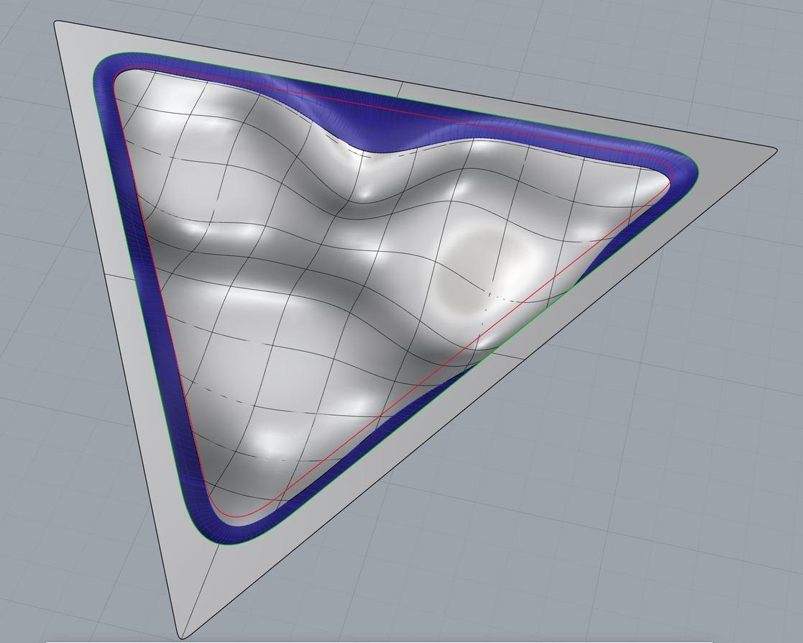
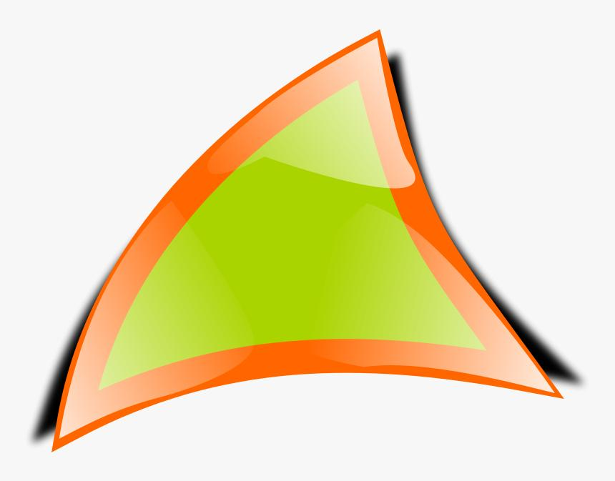
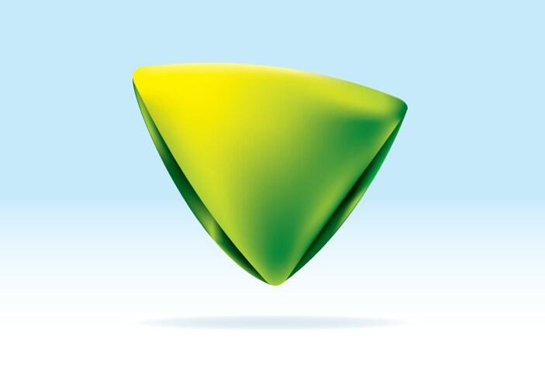
A triangular section is combined with a freely designed curved boundary.

4. Circular–Freeform Mixed Shape
# Source: AI Source: Provided by: [Data Path: Persons Table -> ID Column: 1, Name_En Column: Motasem Essam] -> From: [ChatGPT] on [7/25/2026]
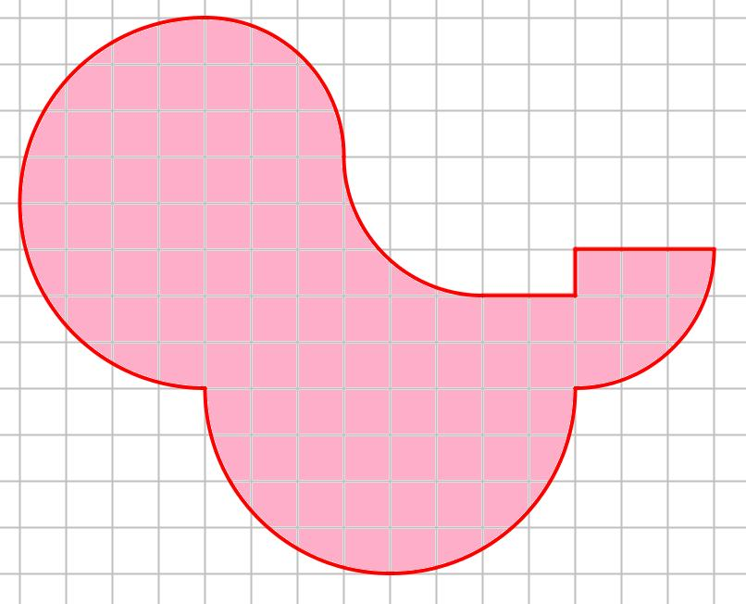
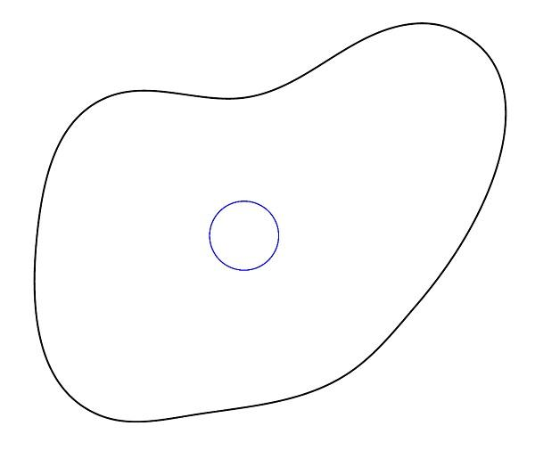
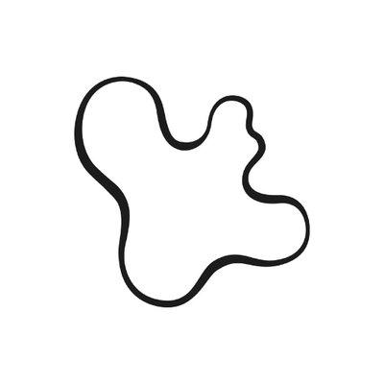
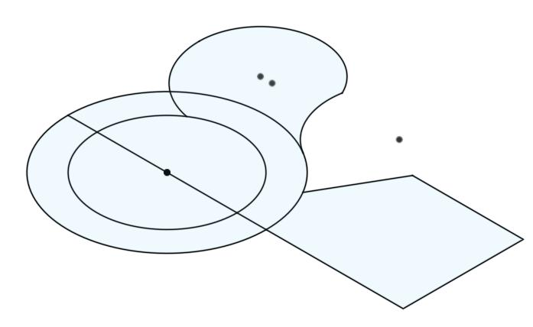
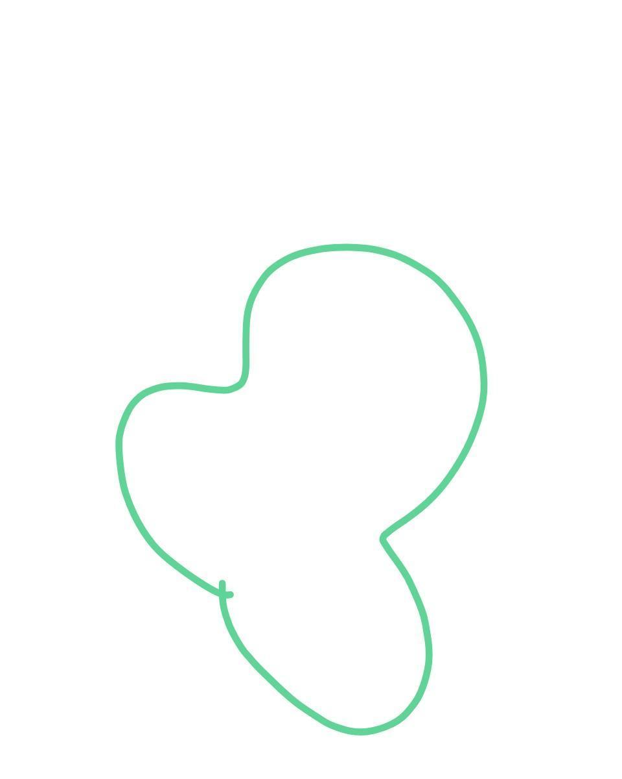
A circular component is combined with a non-circular freeform curve.

5. Polygon–Circular–Freeform Mixed Shape
# Source: AI Source: Provided by: [Data Path: Persons Table -> ID Column: 1, Name_En Column: Motasem Essam] -> From: [ChatGPT] on [7/25/2026]

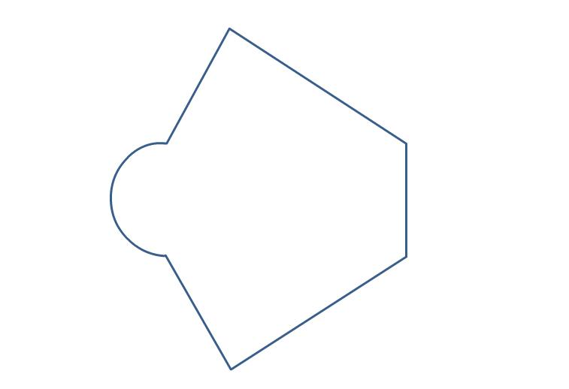

This is a more complex mixed shape containing:
- Straight polygonal segments.
- Circular arcs.
- Freely controlled curves.
$$\boxed{\text{Polygon}+\text{Circular}+\text{Freeform}}$$

6. Organic–Freeform Mixed Shape
# Source: AI Source: Provided by: [Data Path: Persons Table -> ID Column: 1, Name_En Column: Motasem Essam] -> From: [ChatGPT] on [7/25/2026]
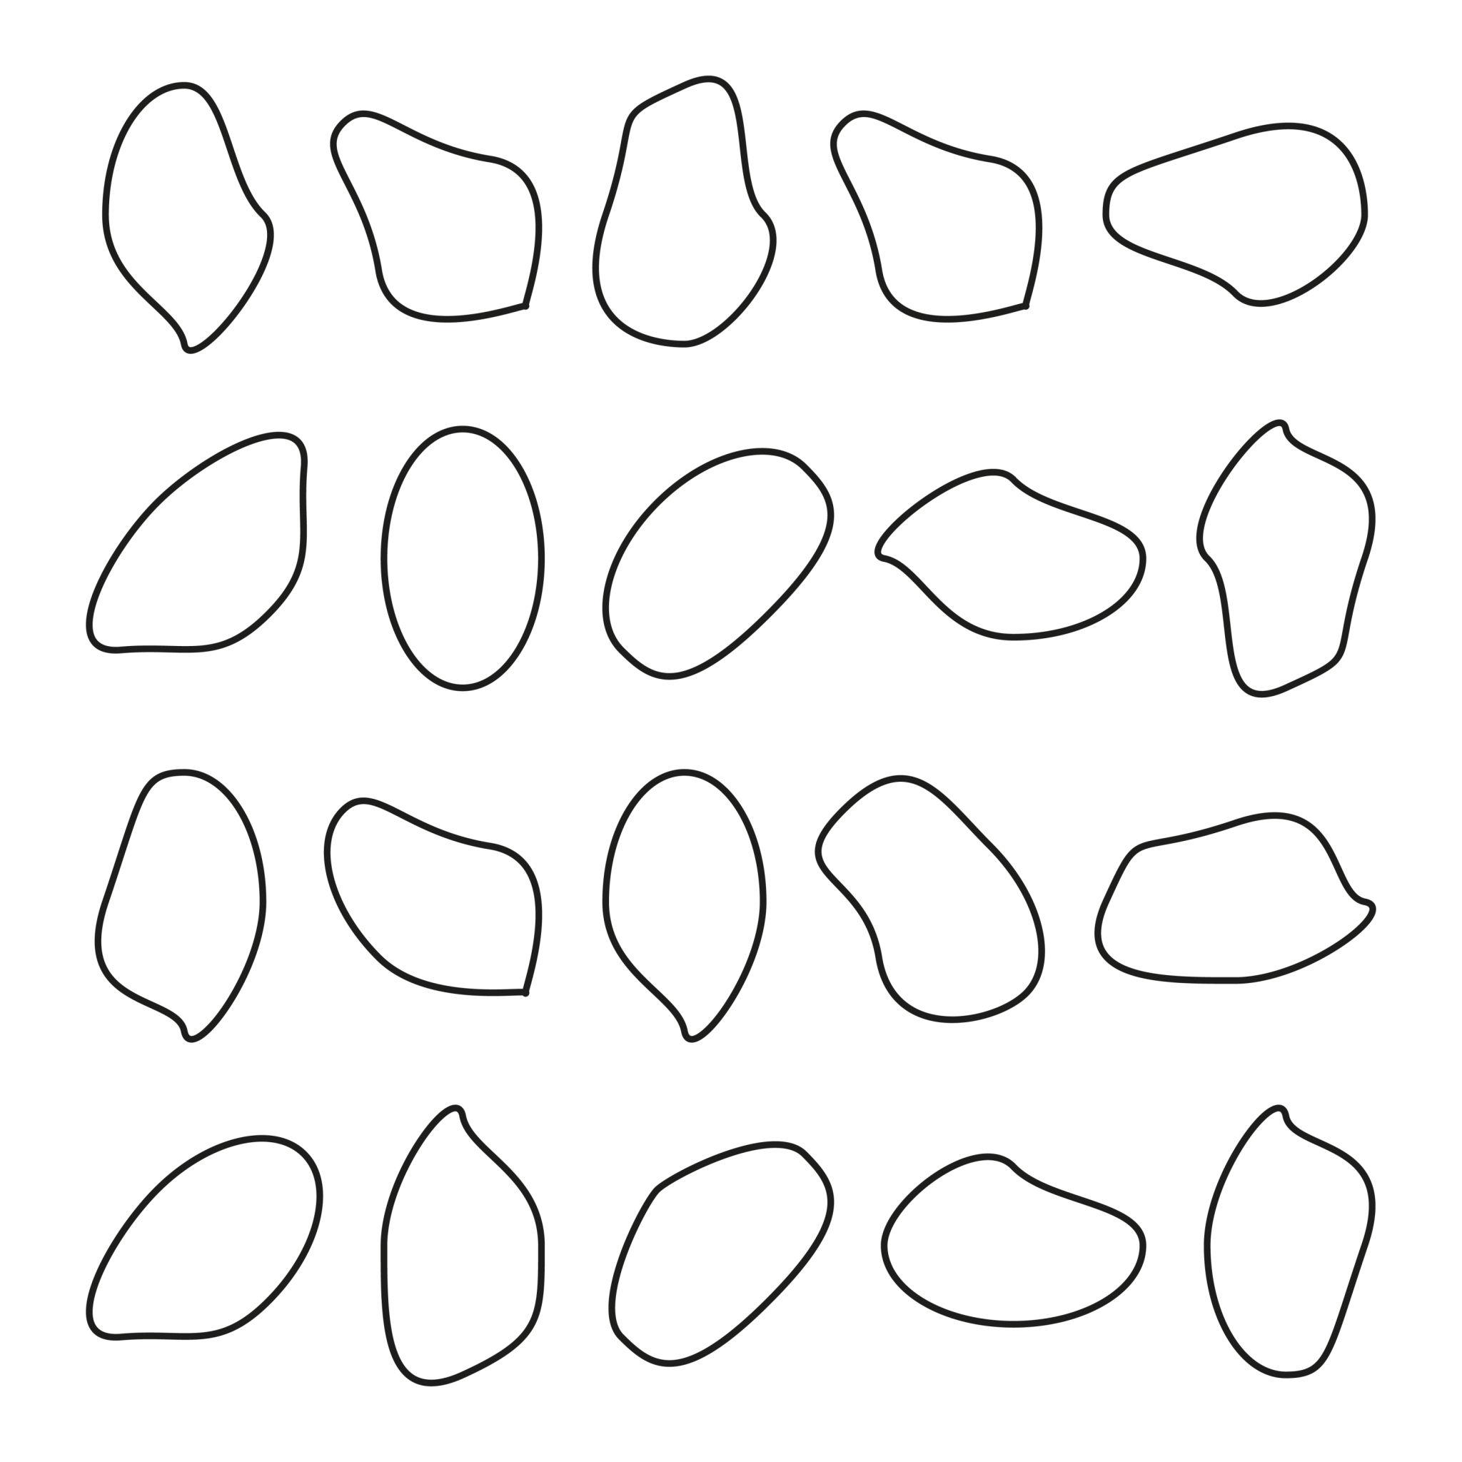

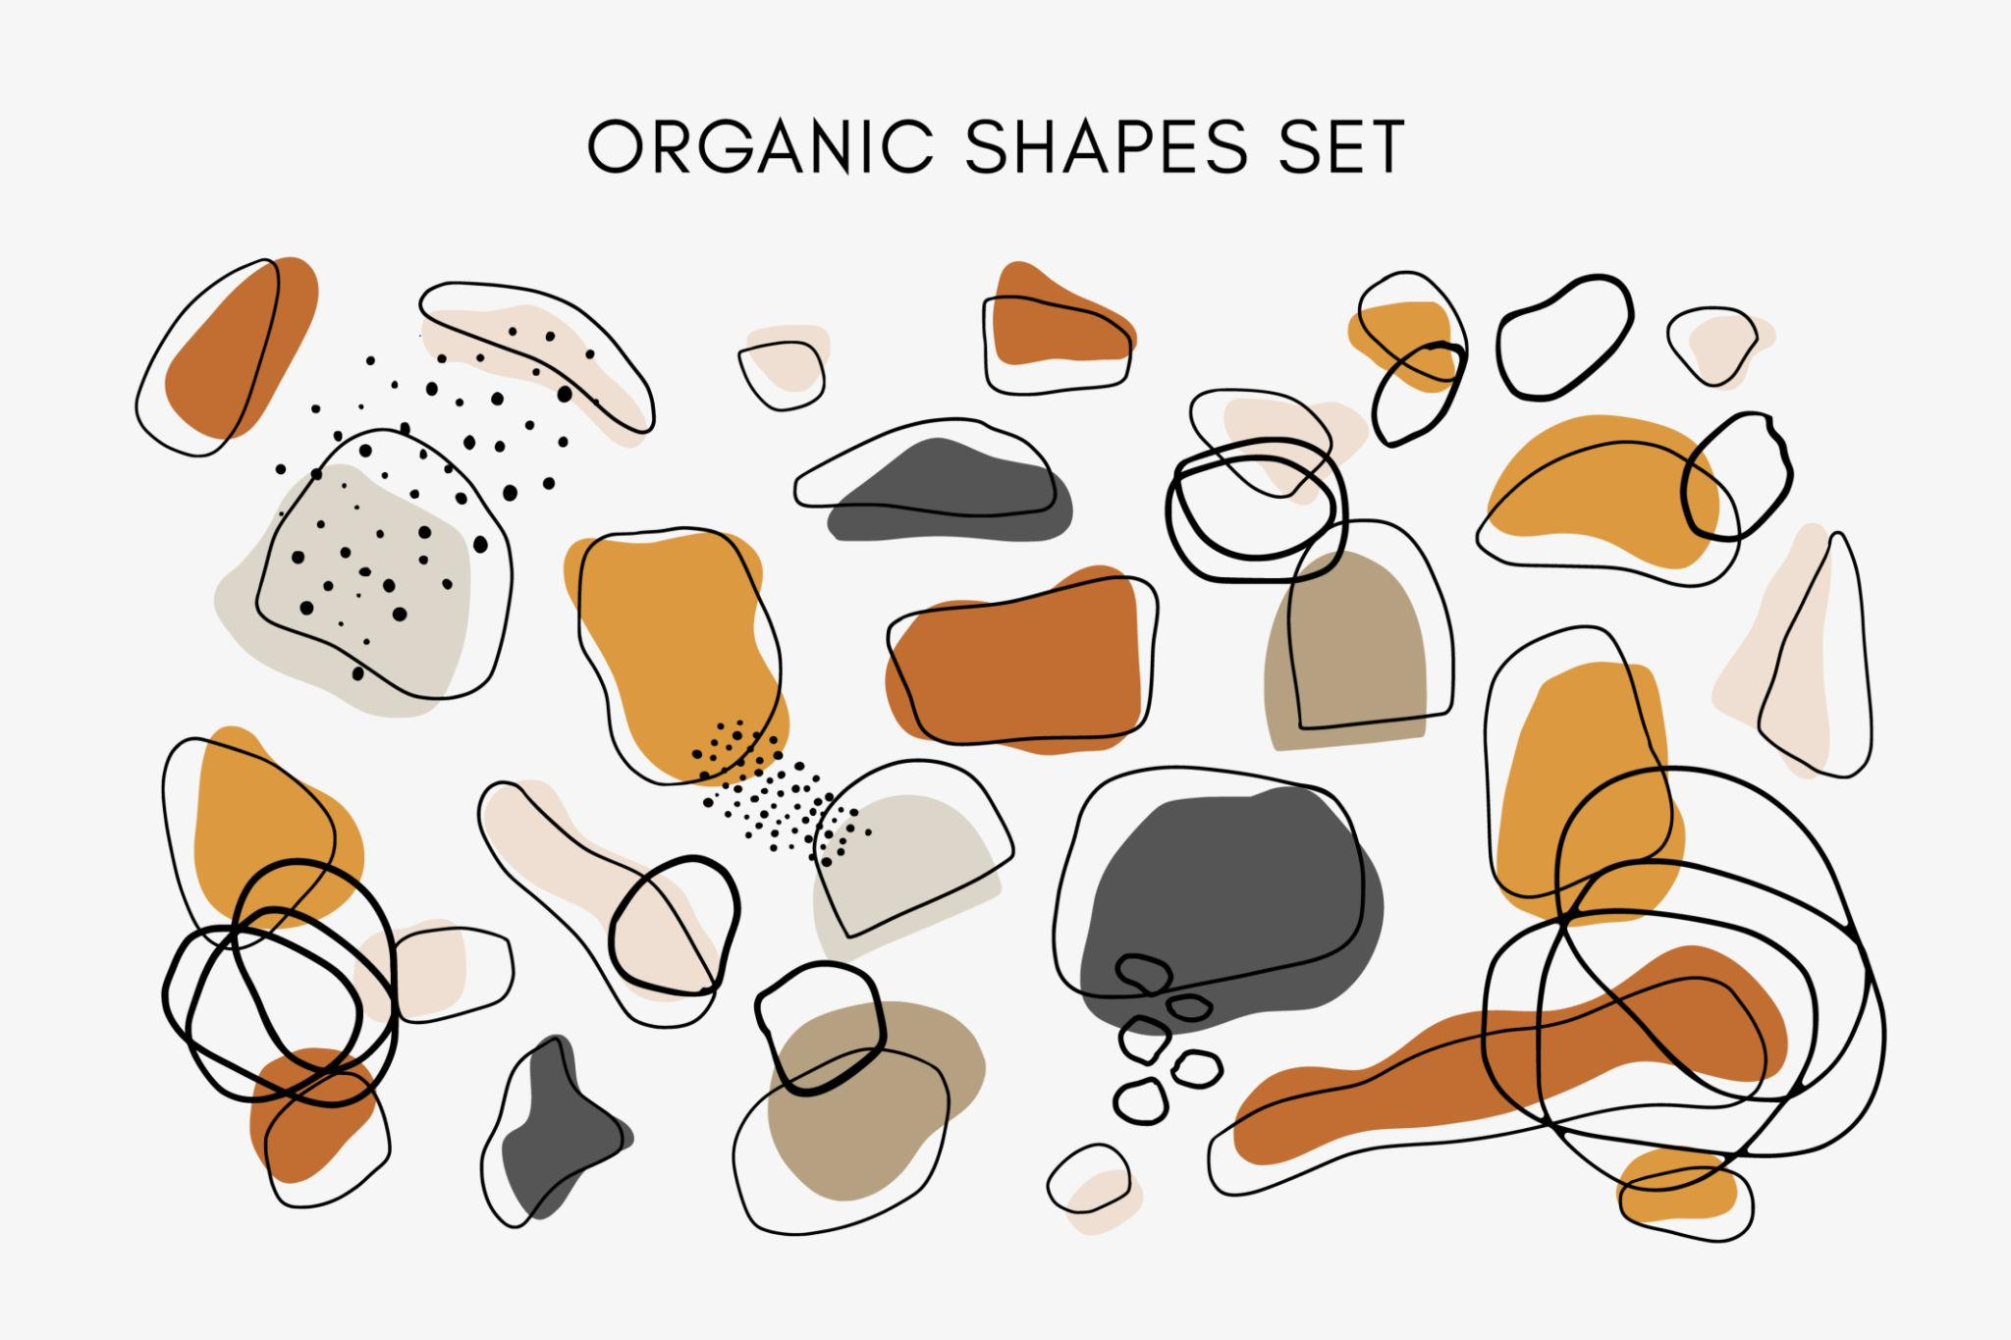
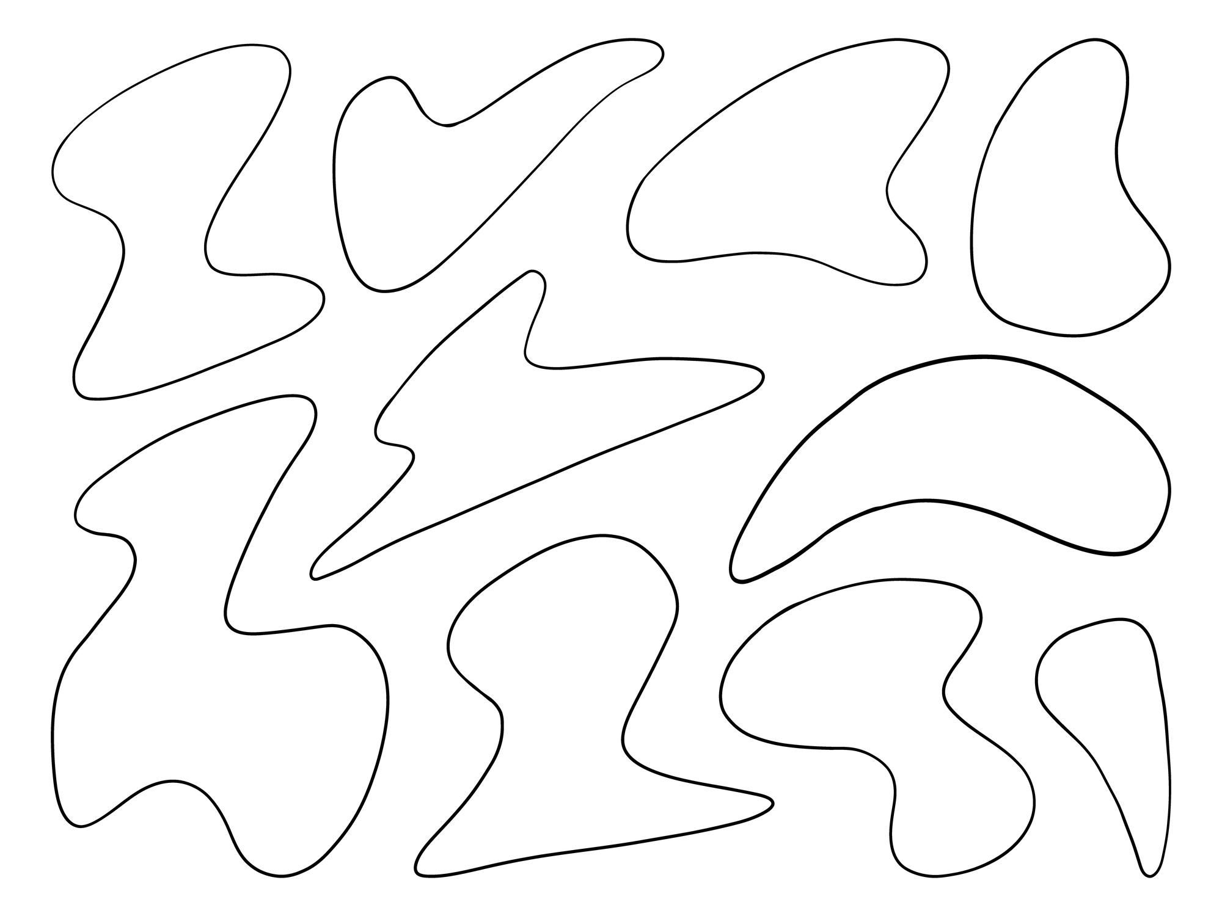
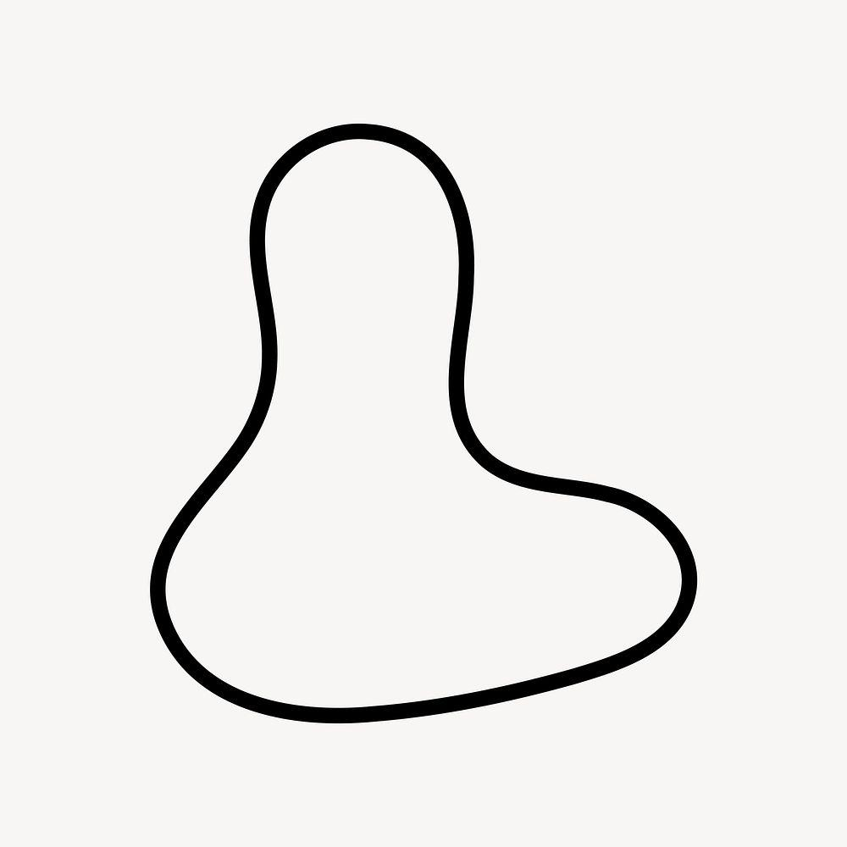
Combines natural-looking organic curves with deliberately controlled freeform geometry.

Boundary Classification
# Source: AI Source: Provided by: [Data Path: Persons Table -> ID Column: 1, Name_En Column: Motasem Essam] -> From: [ChatGPT] on [7/25/2026]
A freeform mixed shape can have several boundary types:
$$\boxed{\text{Boundary}=\text{Straight Segments}+\text{Circular Arcs}+\text{Freeform Curves}}$$
Therefore, it is a particularly broad example of a mixed boundary.

Mathematical Representation
# Source: AI Source: Provided by: [Data Path: Persons Table -> ID Column: 1, Name_En Column: Motasem Essam] -> From: [ChatGPT] on [7/25/2026]
A freeform mixed shape generally cannot be represented by one simple standard equation.
Different portions of its boundary can be represented separately:
Straight section
$$y=mx+b$$
Circular section
$${\left(x-h\right)}^{2}+{\left(y-k\right)}^{2}=r^{2}$$
Freeform section
$$x=x\left(t\right), y=y\left(t\right)$$
The complete boundary can therefore be described as a piecewise combination of different curves.

Area
# Source: AI Source: Provided by: [Data Path: Persons Table -> ID Column: 1, Name_En Column: Motasem Essam] -> From: [ChatGPT] on [7/25/2026]
The area can often be calculated by decomposing the shape into simpler regions:
$$\boxed{A_{\text{total}}=\sum{A_{\text{components}}}}$$
For example:
$$A_{\text{total}}=A_{\text{rectangle}}+A_{\text{circle}}+A_{\text{freeform}}$$
If some components are removed:
[
$$A_{\text{total}}=A_{\text{added}}-A_{\text{removed}}$$]
For a genuinely arbitrary freeform portion, numerical methods or coordinate-based approximation may be required.

Perimeter
# Source: AI Source: Provided by: [Data Path: Persons Table -> ID Column: 1, Name_En Column: Motasem Essam] -> From: [ChatGPT] on [7/25/2026]
The perimeter is the sum of all boundary lengths:
$$\boxed{P=\sum{L_{\text{straight}}}+\sum{L_{\text{circular arcs}}}+\sum{L_{\text{freeform curves}}}}$$
For a freeform parametric section:
$$L=\int_{a}^{b}{\sqrt{{\left(\frac{dx}{dt}\right)}^{2}+{\left(\frac{dy}{dt}\right)}^{2}}}dt$$

Freeform Mixed vs. Polygon–Circular Mixed
# Source: AI Source: Provided by: [Data Path: Persons Table -> ID Column: 1, Name_En Column: Motasem Essam] -> From: [ChatGPT] on [7/25/2026]
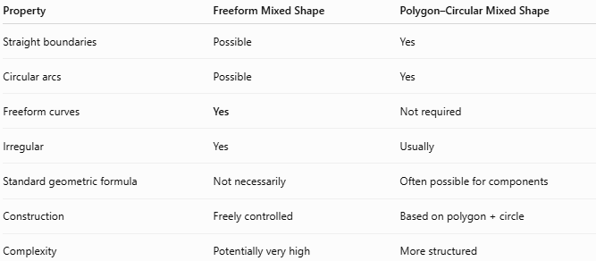
Property | Freeform Mixed Shape | Polygon–Circular Mixed Shape
Straight boundaries | Possible | Yes
Circular arcs | Possible | Yes
Freeform curves | Yes | Not required
Irregular | Yes | Usually
Standard geometric formula | Not necessarily | Often possible for components
Construction | Freely controlled | Based on polygon + circle
Complexity | Potentially very high | More structured

Freeform Mixed vs. Organic Mixed
# Source: AI Source: Provided by: [Data Path: Persons Table -> ID Column: 1, Name_En Column: Motasem Essam] -> From: [ChatGPT] on [7/25/2026]
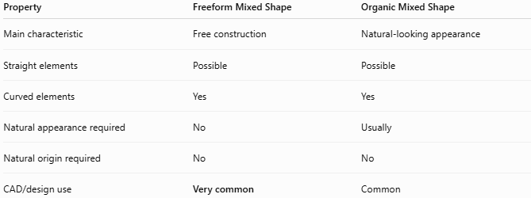
Property | Freeform Mixed Shape | Organic Mixed Shape
Main characteristic | Free construction | Natural-looking appearance
Straight elements | Possible | Possible
Curved elements | Yes | Yes
Natural appearance required | No | Usually
Natural origin required | No | No
CAD/design use | Very common | Common
The important distinction is:
$$\boxed{\text{Freeform}=\text{how the shape is constructed}}$$
while:
$$\boxed{\text{Organic}=\text{how the shape appears}}$$

Key Points
# Source: AI Source: Provided by: [Data Path: Persons Table -> ID Column: 1, Name_En Column: Motasem Essam] -> From: [ChatGPT] on [7/25/2026]
A Freeform Mixed Shape combines different types of geometric elements in a freely controlled irregular form:
$$\boxed{\text{Freeform Mixed Shape}=\text{Straight}+\text{Circular}+\text{Freeform} \text{(in any combination)}}$$
It can contain:
- Straight-line segments.
- Polygonal components.
- Circular arcs.
- Organic curves.
- Bézier curves.
- Spline curves.
- Other freely controlled boundaries.

Conclusion
# Source: AI Source: Provided by: [Data Path: Persons Table -> ID Column: 1, Name_En Column: Motasem Essam] -> From: [ChatGPT] on [7/25/2026]
Freeform Mixed Shapes are irregular composite shapes whose boundaries or components are created using freely controlled combinations of different geometric elements. They can combine straight segments, polygonal sections, circular arcs, and organic or spline-based curves. Because their boundaries are not restricted to a single standard geometric form, they are especially useful for representing complex forms in CAD, engineering, architecture, product design, computer graphics, illustration, and real-world objects.

